**Chapter 4**

1. Consider sending a 1,600-byte datagram into a link that has an MTU of 500 bytes. Suppose the original datagram is stamped with the identification number 291. How many fragment are generated? What are the values in the various field in the IP datagram(s) generated related to fragmentation?

**Answer:**

The maximum size of data field in each fragment = 480 (because there are 20 bytes IP

header). Thus the number of required fragments = 

Each fragment will have Identification number 291. Each fragment except the last one

will be of size 500 bytes (including IP header). The last datagram will be of size 160

bytes (including IP header). The offsets of the 4 fragments will be 0, 60, 120, 180. Each of the first 3 fragments will have flag=1; the last fragment will have flag=0.

1. Consider the SDN OpenFlow network shown below. Suppose that the desired forwarding behavior for datagrams arriving at s2 is as follows:

* Any datagrams arriving on input port 1 from hosts h5 or h6 that are destined to hosts h1 or h2 should be forwarded over output port 2;
* Any datagrams arriving on input port 2 from hosts h1 or h2 that are destined to hosts h5 or h6 should be forwarded over output port 1;
* Any arriving datagrams on input ports 1 or 2 and destined to hosts h3 or h4 should be delivered to the host specified;
* Host h3 and h4 should be able to send datagram to each other.

Specify the flow table entries in s2 that implement this forwarding behavior.

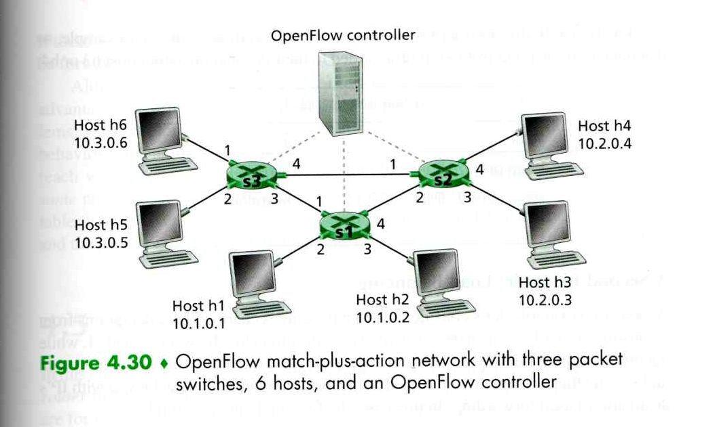

**Answer:**

